Project Proposal

Project Name: Little Creek E. Bryan Street Fish Passage

Project Sponsor:
Grande Ronde Model Watershed Foundation (GRMWF)
1114 J Avenue
La Grande, OR 97850
541-663-0570
541-962-1585 (f)

Participating Entities
Grande Ronde Model Watershed Program (GRMWP)
City of Union (owner)
Union County (construction)
Anderson Perry & Associates (designs)

Project Contact(s):
Grande Ronde Model Watershed Program (technical)
- Lyle Kuchenbecker, 541-663-0570, lyle@grmw.org

Grande Ronde Model Watershed Foundation (administrative)
- Lyle Kuchenbecker, 541-663-0570, lyle@grmw.org
- Mary Estes, 541-663-0570, mary@grmw.org

City of Union
- Paul Phillips, 541-910-0091, phillips@cityofunion.com

Union County
- Steve McClure, 541-963-1001, smcclure@union-county.org

Introduction and Background
Little Creek is a tributary to Catherine Creek and supports Snake River summer steelhead, resident rainbow trout and other native fish species. Current steelhead production is unknown but the system was known in have spawning steelhead in the past. ODFW tallied 21steelhead redds in a 1966 survey. Tim Bailey, ODFW NE Region District Fish Biologist feels due to the lateness of the survey that year that many redds could have been missed. The existing culverts frequently plug with debris and ice resulting in out-of-channel flow. The Grande Ronde Model Watershed (GRMW), City of Union, Union County Public Works Department and Bonneville Power Administration (BPA) propose to correct the problem by replacing the current structure with a 22-foot channel-spanning steel bridge.

Existing Condition
The existing crossing consists of three approximately 25-foot long, 70-inch diameter culverts arranged side-by-side. The culverts appear to be squashed CMP’s that are partially buried. Moderately high flow events come close to maxing out the capacity of the pipes. Ice and debris frequently plug the culverts resulting in out-of-channel flow, flooding adjacent properties and resulting in substantial flow running down E. Bryan Street to the west. The out-of-channel flows occur nearly every year and often more than once throughout each winter and spring. When out-of-channel flows coincide with steelhead out-migration it is likely a significant number of steelhead juveniles are lost.

Project Location:
Legal description: T4S, R40E, Sec. 18, SW ¼ of the NE ¼

Project Objectives:
- Reduce potential for seasonal out-of-channel flow and fish stranding
- Provide continuous fish passage during peak flows for all life stages of salmonids and other native species.
- Reduce water quality impacts
- Reduce flood impacts to local properties.

Proposed Actions:
The GRMW has contracted with Anderson Perry & Associates (AP) to provided engineering services. AP conducted a site survey and a hydrologic assessment, and has presented preliminary alternatives to the GRMW, City of Union and Union County PWD. There are two alternative designs.

One design is a bottomless concrete box culvert spanning 22 feet and 26 feet long. The second design is a full-span steel bridge with the same dimensions. The City and County agreed that they preferred the steel bridge option. The steel bridge is slightly lower in cost and is of a design that Union County Public Works has constructed at over a dozen sites.

The preferred steel bridge alternative consists of the following actions:
- Excavate for footings approximately 40 feet long and 6-feet deep on each side of the channel
- Relocate water, sewer and gas lines as necessary (may need to be relocated about 6 feet outside of bridge footings on the south side)
- Install stream simulation rock in the streambed under, and extending in the channel on either side of the bridge.
- Elevate road grade approximately two feet and taper out approximately 100 feet on either side of the bridge(the bridge will need to be one foot higher than the current road level).
- Install new steel bridge with guardrails
- Repave the new roadbed with asphalt.

The project is planned to be implemented during the prescribed ODFW in-water work window of July 1 to October 15, 2011. The GRMW will request construction funds from BPA and possibly other sources. The City of Union has acquired a $25,000 grant from ODOT and will also provide in-kind labor and materials to move the utility lines. Union County PWD will construct the bridge and subcontract the asphalt paving.

Environmental Compliance
The GRMW, in coordination with BPA, will conduct all environmental compliance activities. The GRMW has contracted for a Cultural Resource survey and report which will be submitted to BPA and on to Oregon State Historic Preservation Office (SHPO), CTUIR and the Nez Perce Tribe. SHPO Section 106 Cultural Resource clearance will be obtained prior to implementation. The design process is nearly complete. 90% designs have been sent to NOAA Fisheries and ODFW fish passage engineers. Final designs will be developed in coordination with NOAA and ODFW passage engineers. The GRMW has received fish passage approval from both NOAA and ODFW passage engineers. The GRMW is pursuing ESA consultation via the USFWS Partners for Wildlife Program programmatic Biological Opinion.

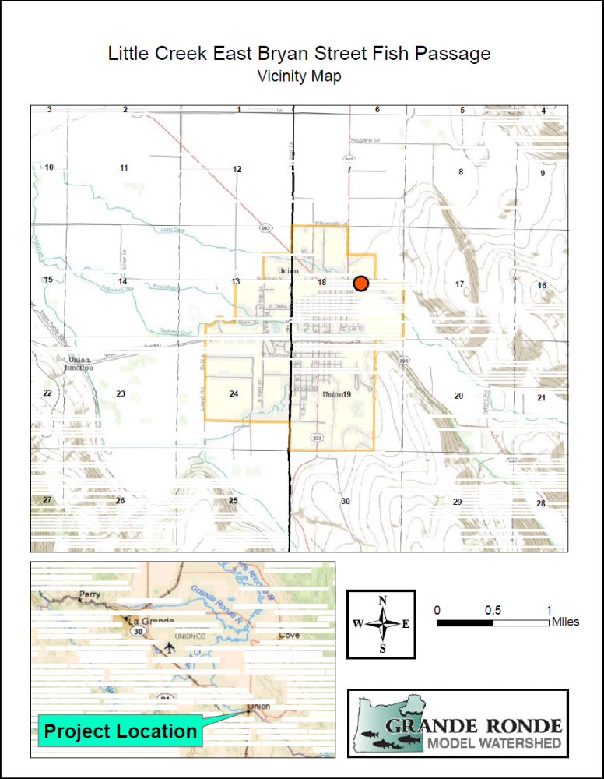

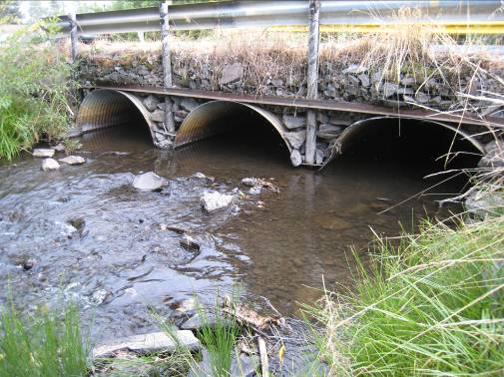
View of downstream end of the culverts. There is no fish passage problem at low and moderate flows

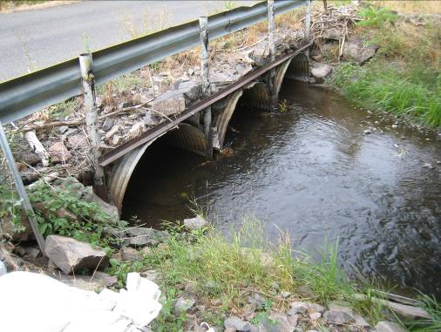
View of upstream side. The configuration of the pipes is very conducive to accumulation of debris and ice.
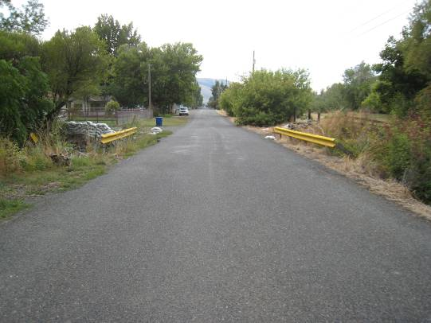
View looking west across the bridge and down E. Bryan Street

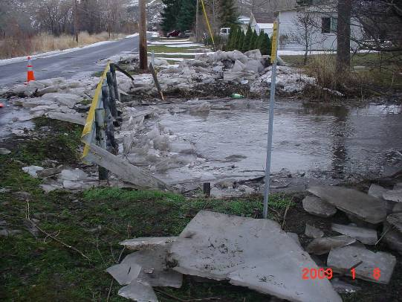
January 2009
Ice and debris jam and out-of-channel flow

